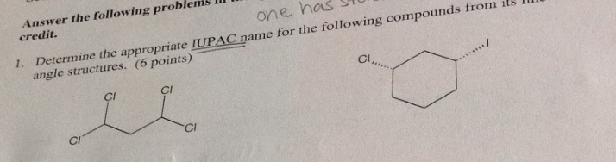
Ans.

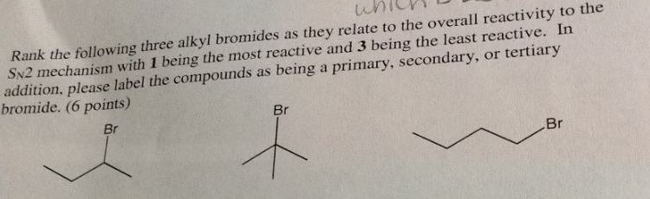
Most reactive Least Reactive
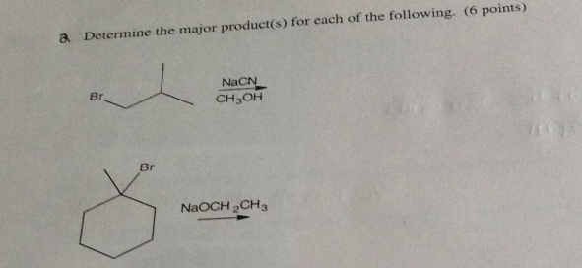
Ans.
(SN2 Mechanism)

[E2 Elimination, More substituted alkene is favoured (Zaitsev’s Rule)]

